

University of Electronic Science and Technology of China (UESTC)



**FINAL REPORT**

**FILTER SPECIFICATIONS AND DESIGNING A DIGITAL FILTER BASED ON THE GIVEN SPECIFICATIONS**

by

**Student Name: Igiraneza Esperance**

**Student ID No： 201424010111**

**Course: Digital signal processing**

**Major： Communication and Information Engineering**

***Date: 2014- 12-18***

**CONTENT**

1. **INTRODUCTION**
2. **DEFINITION**
3. **TYPES OF FILTER SPECIFICATIONS**
4. **DIGITAL FILTER DESIGN**
5. **SPECIFICATIONS AND DESIGN OF IIR FILTERS**
6. **TYPES OF APPROXIMATIONS UISNG BILINEAR TRANSFORMATION METHOD**
7. **CONCLUSION**

**REFERENCE**

1. **INTRODUCTION**

Analog filters are types of hardware that pass through signals with some frequency components while rejecting other frequency components in which you obtain filter specification. The specification is developed based on the technical requirements to the filter and the possibility of hardware realization.

For most digital filters, you typically design the digital filter response in the frequency domain. The frequency response specification for the digital filter typically includes the target magnitude response, phase response, and the allowable deviation for each.

1. **DEFINITION**

A filter specification is a technical specification that determines the pass-band and stop-band frequency ranges and acceptable attenuations in those ranges.

Generally, filter specifications determine pass band and stop band frequency ranges, desirable signal attenuations (gains) at those ranges, approximation methods for the filter design, and hardware implementation requirements.

The frequency ranges in which signals pass through are named filter pass-band, and frequency ranges in which signals are rejected are named stop-band. In practical filters, signals attenuate in the pass-band as well as in the stop-band. The signal attenuations in the pass-band should not exceed some low level. In the stop-band, signal attenuations must not be smaller than the determined level.

1. **TYPES OF FILTER SPECIFICATIONS**

There are four basic types of filter specifications, one for each of the four basic filter types:

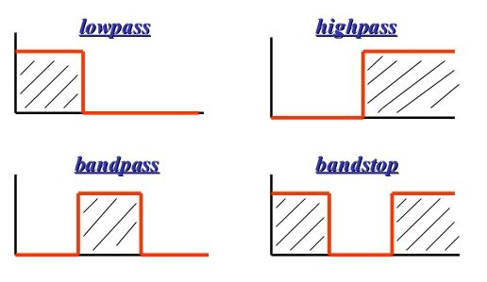

* **Low-pass specifications**

Ideal low-pass filters pass low frequency signals up to a determined cutoff frequency, and attenuate signals beyond it. Ideal low-pass filters are unrealizable due to the fact that when frequencies change from pass band to the stop band, the gain(reflection) is a jump that results in a discontinuous transition. Practical low-pass filter specifications specify the transition band where filter gain (attenuation) continuously changes from pass band gain to stop band gain.

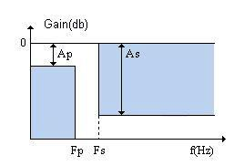

**Ap, As -** passband and stopband attenuations.

**0 < f < Fp -** passband **Fp < f < Fs -** transition band **f > Fs -** stopband

The practical low-pass filter specification is determined by four parameters: **Ap, Fp, As, Fs.** Pass band edge frequency **Fp** describes a frequency below which the signal must pass through a filter with attenuation that does not exceed **Ap**. Usually, the attenuation **Ap** in the pass band changes in the range **0 < Ap < 1(db)** .

All frequency components above stop band edge frequency **Fs** must be attenuated. The attenuation in the stop band must be at least **As**. The attenuation for high quality low-pass filters can be **60 - 80 db**. The behavior of the system in the transition band is not specified. The shorter the transition band, the better the practical filter is.

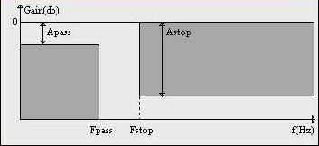

* **High-pass specifications**

Ideal high-pass filters attenuate frequency components up to a determined cutoff frequency, and pass signals beyond it well. Ideal high-pass filters are unrealizable due to the fact that when frequencies change from stop band to the pass band, the gain(attenuation) is a jump that results in a discontinuous transition. Practical high-pass filters specify the transition band where filter gain (attenuation) continuously changes from stop band gain to pass band gain.

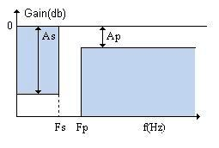

#### Ap, As - passband and stopband attenuations.

#### 0 < f < Fs - stopband Fs < f < Fp - transition band f > Fp - passband

The practical high-pass filter specification is determined by four parameters: **Ap, Fp, As, Fs**. The frequency components below the stop band edge frequency **Fs** must be attenuated. The attenuation in the stop band must be above **As**. The attenuation for high quality high-pass filters must be at least **60 - 80 db**. All frequency components above pass band edge frequency **Fp** must pass well. Usually, pass band attenuations for practical filters do not exceed **1 db**. The behavior of the system in the transition band is not specified. The shorter the transition band, the better the practical filter is.

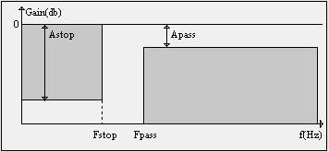

* **Band-pass specifications**

Ideal band-pass filters pass signals from certain lower to upper frequency points well, and attenuate signals outside of that range. Since ideal filters cannot be realized in hardware, practical bandpass filters introduce transition ranges adjacent to the frequencies which determine pass band.

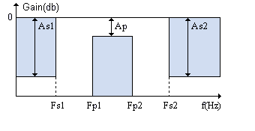

#### Ap - passband attenuation.

#### As1, As2 - stopband attenuations.

#### 0 < f < Fs1, f > Fs2 - stopbands Fp1 < f < Fp2 - passband Fs1 < f < Fp1, Fp2 < f < Fs2 - transition bands

The practical band-pass filter specification is determined by seven parameters: **As1, Ap, As2, Fs1, Fp1, Fp2, Fs2**. The pass band is determined by edge frequencies **Fp1, Fp2** and passband attenuation **Ap**. The left stop band is determined by attenuation As1 applied to the frequencies in the range **0 < f < Fs1**.

The right stop band is determined by attenuation **As2** applied to the frequencies in the range **f > Fs2**.

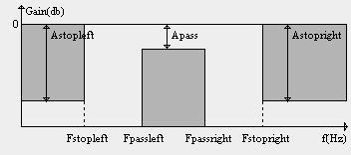

* **Band-stop specifications.**

Ideal band-stop (or band-reject) filters are used for attenuating (rejecting) the frequency components in a certain range. Outside of that range, signals pass with no attenuation. Practical band-stop filters introduce transition bands adjacent to frequencies which determine the stop band.

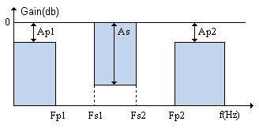

#### Ap1,Ap2 - passband attenuations.

#### As - stopband attenuation.

#### 0 < f < Fp1, f > Fp2 - passbands Fs1 < f < Fs2 - stopband Fp1 < f < Fs1, Fs2 < f < Fp2 - transition bands

The practical band-stop filter specification is determined by seven parameters: **Ap1, As, Ap2, Fp1, Fs1, Fs2, Fp2**. The stop band is determined by edge frequencies **Fs1**, **Fs2** and attenuation **As**. The left pass band is determined by attenuation **Ap1** applied to the frequencies in the range **0 < f < Fs1**. The right pass band is determined by attenuation **Ap2** applied to the frequencies in the range **f > Fp2**.

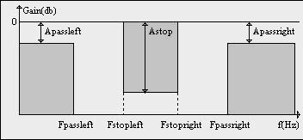

1. **DIGITAL FILTER DESIGN**

The most important step in the development of a digital filter : Determine a realizable transfer function **G(z)**

**Digital Filter Specifications:**

Magnitude response specifications in the passband and the stopband are given with some acceptable tolerances. A transition band is specified between the passband and the stopband to permit the magnitude to drop off smoothly.

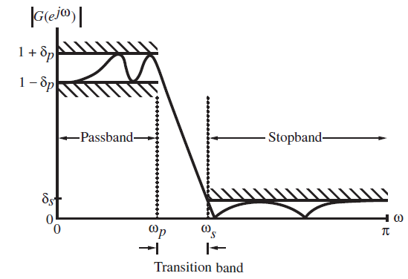

* **Passband edge frequency**



* **Stopband edge frequency**



* **Peak ripple value of passband**



* **Peak ripple value of stopband**



* **Peak passband ripple**
* **Minimum stopband attenuation**



* **Sample frequency FT**



* **Selection of the Filter Type**

The objective of digital filter design is to develop a causal transfer function H(z) meeting the frequency specifications.

* FIR and IIR Digital Filter

- FIR Digital Filter

- IIR Digital Filter



|  |  |  |
| --- | --- | --- |
|  | **FIR** | **IIR** |
| **Impulse Response** | **Finite** | **infinite** |
| **System Function** | **H(z)=P(z)** | **H(z)=P(z)/D(z)** |
| **Structure diagram** | **Have feedback** | **No feedback** |
| **Phase response** | **Exact linear phase**  **h[n]= h[n-N]** | __________________ |
| **Zero-poles** | **Only have zeros** | **Both zeros and poles** |

The order NFIR of an FIR filter is higher than the order NIIR of an equivalent IIR filter meeting the same magnitude specifications.

The ratio NFIR/ NIIRis typically of the order of 10 or more (the IIR filter usually is computationally more efficient).

* **Basic Approaches to Digital Filter Design**

Step1: convert the digital filter specifications into analog lowpass prototype filter specifications.

Step2: determine the analog lowpass filter transfer function Ha(s).

Step3: transform Ha(s) into the desired digital filter transfer function G(z).

-Why analog?

(1)Analog approximation techniques are highly advanced

(2)They usually yield closed-form solutions

(3)Extensive tables are available for analog filter design

(4)Many applications require the digital simulation of analog filters

-How to convert an analog prototype transfer function Ha(s) into a digital IIR transfer function G(z)?

(1) The imaginary $j(Ω)$ axisin the s-plane be mapped onto the unit circle of the z-plane

(2) A stable analog transfer functon be transformed into a stable digital transfer function.

* **Estimation of the Filter Order**

IIR: The order of G(z) is determined from the transformation being used to convert Ha(s) into G(z).

* FIR (lowpass digital filter):
$$N≅\frac{-2\log_{10\left(\sqrt{δ_{p}δ_{s}}\right)-13}}{14.6(ω_{s}-ω_{p})/2π}$$

* For narrowband filter
$$N≅\frac{-2\log_{10\left(δ_{s}\right)+ 0.22}}{(ω_{s}-ω_{p})/2π}$$

* For wideband filter

$$N≅\frac{-2\log_{10\left(δ_{p}\right)+ 5.94}}{27(ω_{s}-ω_{p})/2π}$$

1. **SPECIFICATIONS AND DESIGN OF IIR FILTERS**

The most commonly used IIR filter design method uses reference analog prototype filter. It is the best method to use when designing standard filters such as low-pass, high-pass, bandpass and band-stop filters. The filter design process starts with specifications and requirements of the desirable IIR filter. A type of reference analog prototype filter to be used is specified according to the specifications and after that everything is ready for analog prototype filter design.

Four basic types of ideal filters with magnitude responses as shown below:



These filters are unrealizable because (one of the following is sufficient) their impulse responses infinitely long non-causal. Their amplitude responses cannot be equal to a constant over a band of frequencies. Another perspective that provides some understanding can be obtained by looking at the ideal amplitude squared.

Consider the ideal LP response squared (same as actual LP response).



The realisable squared amplitude response transfer function (and its differential) is continuous in



Such functions

* if IIR can be infinite at point but around that point cannot be zero.
* if FIR cannot be infinite anywhere.

Hence previous differential of ideal response is unrealizable. A realizable response would effectively need to have an approximation of the **delta functions** in the differential. This is a necessary condition.

For example the magnitude response of a digital lowpass filter may be given as indicated below:



In the **passband $0≤ω≤ω_{p}$** we require that $\left|G\left(e^{jω}\right)\right|≅1$ with a deviation $±δ_{p}$**.**

In the **stopband $ω_{s}≤ω≤π$** we require that $\left|G\left(e^{jω}\right)\right|≅0$ with a deviation $δ_{s}$**.**

$$\left|G\left(e^{jω}\right)\right|≤δ_{s}, ω_{s}≤|ω|≤π$$

* **Filter specification parameters**
* $ω_{p}$- passband edge frequency
* $ω_{s}$- stopband edge frequency
* $δ_{p}$- peak ripple value in the passband
* $δ_{s}$- peak ripple value in the stopband

Practical specifications are often given in terms of loss function (in dB), Peak passband ripple and Minimum stopband attenuation.

**Loss function (in dB)** :



**Peak passband ripple:** dB

**Minimum stopband attenuation:** dB



In practice, passband edge frequency $F_{p}$ and stopband edge frequency $F_{S}$ are specified in Hz. For digital filter design, normalized bandedge frequencies need to be computed from specifications in Hz using**:**



**An example:**

Let $F_{p}=7$ kHz**, $F_{S}=3$** kHz and $F_{T}=25$ kHz



1. **TYPES OF APPROXIMATIONS UISNG BILINEAR TRANSFORMATION METHOD**

The use of bilinear transformation is restricted to the design of approximations to filters with piecewise-constant frequency magnitude characteristics, such as highpass, lowpass and bandpass filters.

**Example of bilinear transformation**

* Butterworth Filter and Approximation
* Chebyshev Filter and Approximation
* Elliptic Filter and Approximation



* **Bilinear Transformation of a Butterworth Filter**



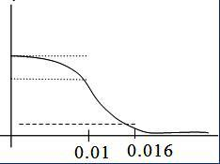



**Locations of Poles**



** Pole pairs:**







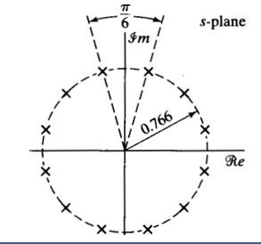



** Pole pairs:**









**frequency response of discrete-time filter**

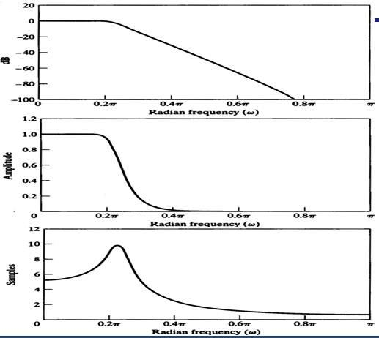

* **Butterworth Approximation (Hw)**



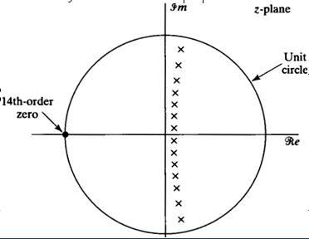

**Frequency response**

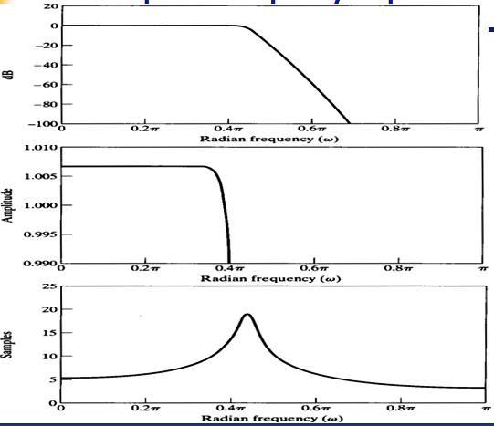

* **Chebyshev filters**
* **Chebyshev filter (type I)**





**Chebyshev polynomial**

* **Chebyshev filter (type II)**



* **Chebyshev Type I , II Approximation**



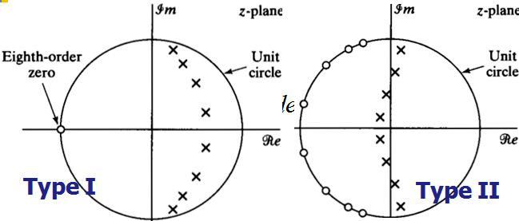

**Frequency response of Chebyshev**

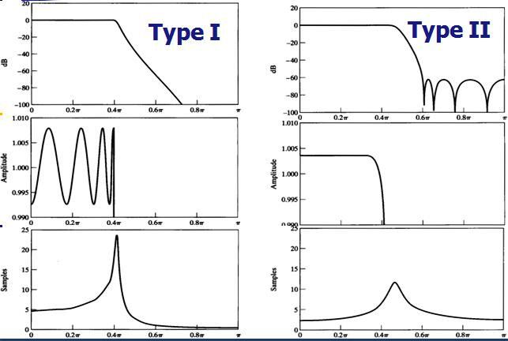

* **Elliptic filters**





**Jacobian elliptic function**

* **Elliptic Approximation**



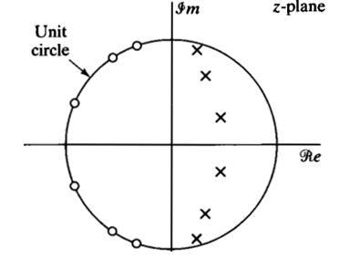

**Frequency response of Elliptic**

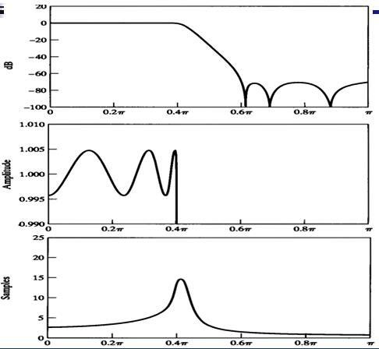

* **Comparison of Butterworth, Chebyshev, Elliptic filters: Example**
* **Given specification**



**-Order**

**Butterworth Filter :** N=14. ( max flat)

**Chebyshev Filter :** N=8. ( Cheby 1, Cheby 2)

**Elliptic Filter : N=6**  ( equiripple)

1. **CONCLUSION**

In IIR filters, the approximation problem is usually solved through indirect methods. First, a continuous-time transfer function that satisfies certain specifications is obtained using one of the standard analog-filter approximations.

A corresponding discrete-time transfer function is obtained using bilinear transformation.

Here the bilinear transformation is used and is concerned with the indirect approach to the design of IIR filters

**REFERENCE**

1. <http://www.slideshare.net/bhaanesh/introduction-to-filters?qid=082bcd98-0448-46da-8cef-61abd2763ee0&v=default&b=&from_search=1>
2. <http://www.matheonics.com/Tutorials/Specification.html#Paragraph_2.6>
3. <http://www.mikroe.com/chapters/view/73/chapter-3-iir-filters/>.
4. [www.commsp.ee.ic.ac.uk/...Digital%20Filter%20Design/1-Digital%20filters%20(FIR)](http://www.commsp.ee.ic.ac.uk/...Digital%20Filter%20Design/1-Digital%20filters%20(FIR))
5. control.sdu.edu.cn/.../Chapter%207%20Filter%20Design%20Techniques